
Lebanese American University
Department of Computer Science & Mathematics
Artificial Intelligence Fall 2025
Instructor: Dr. Abbas Rammal
Project Report by Karim Rahal & Sarah Dhainy
Project Title:
American Sign Language Classification Using CNNs and Transfer Learning with K-Fold Cross-Validation
1. Project Overview
This project focuses on building a deep learning system capable of recognizing American Sign Language (ASL) hand gestures from images. The system aims to classify 29 different classes, including alphabet letters (A–Z) and the gestures space, nothing, and del. The task is a challenging visual recognition problem due to variations in lighting, background noise, hand orientation, and user differences.
Deep neural networks, particularly Convolutional Neural Networks (CNNs) and modern transfer learning architectures—are highly suitable for this task because they automatically learn hierarchical spatial features from images, such as edges, shapes, textures, and gesture-specific patterns. In this project, four architectures were implemented and compared:
- A Custom CNN designed from scratch
- ResNet50
- EfficientNetB0
- MobileNetV3
The goal is to identify which model yields the best performance and efficiency when trained on a large-scale sign-language dataset using K-Fold cross-validation.
2. Problem Definition and Objectives
2.1 Why Sign Language Recognition Is Important
Sign language enables millions of people with hearing impairments to communicate effectively. However, communication barriers often occur between hearing and non-hearing individuals. An automated sign-language recognition system can support inclusivity by enabling real-time translation, improving accessibility in public services, education, and technology. Creating such a system represents a step toward reducing communication inequalities.
2.2 AI Perspective on the Problem
From an artificial intelligence standpoint, gesture recognition is complex because it requires a model to identify subtle differences in hand shape, orientation, and posture. Deep learning models—especially convolutional architectures—excel at extracting spatial features, making them ideal for high-resolution image classification tasks such as sign recognition. Transfer learning models further enhance performance by utilizing pretrained feature extractors that generalize well even with variations in background, lighting, and hand appearance.
2.3 Project Objectives
- Build and train four deep learning models (CNN, ResNet50, EfficientNetB0, MobileNetV2) on the ASL dataset.
- Apply 5-Fold Cross-Validation with the Adam optimizer to ensure robust generalization performance and avoid overfitting.
- Compare performance between a custom CNN and state-of-the-art transfer learning models.
- Evaluate the models using accuracy, precision, recall, F1-score, and confusion matrices.
- Visualize learning curves and analyze training behavior (overfitting vs. underfitting).
- Identify the best-performing architecture and propose potential improvements for future iterations.
3. Theoretical Background
Perceptron and Activation Functions
A perceptron computes a weighted sum of inputs followed by a nonlinear activation.
In this project:
- ReLU is used in all hidden layers because it prevents vanishing gradients and accelerates training.
- Softmax is used in the final layer since the problem is multi-class classification (29 classes).

Backpropagation
All models learn by minimizing the categorical crossentropy loss using gradient descent. Backpropagation computes gradients of each weight efficiently, allowing the network to adjust parameters during training.
Training Hyperparameters
- Epochs (25): Enough time for convergence while preventing overfitting due to regularization.
- Learning Rate (0.0001): A small value to ensure stable, smooth learning for deep pre-trained models.
- Batch Size (32): Balanced memory usage and gradient stability on the L4 GPU.
- Regularization: Dropout (0.4–0.5) and BatchNormalization prevent overfitting and stabilize training.
CNN and Transfer Learning
- Custom CNN extracts features through convolution, pooling, and dropout layers.
- ResNet50 uses residual connections to solve vanishing gradients.
- EfficientNetB0 scales width, depth, and resolution efficiently.
- MobileNetV2 is optimized for lightweight and mobile applications through bottlenecks and inverted residuals.
4. Methodology
4.1 Tools and Frameworks
- Python
- TensorFlow / Keras
- NumPy, Pandas
- Matplotlib / Seaborn for visualization
- Google Colab Pro (L4 GPU) for high-performance training
- KFold (sklearn) for cross-validation
- Glob, OS, Pickle for checkpointing and history saving
These tools were chosen because TensorFlow provides strong support for transfer learning and GPU acceleration, while Colab Pro offers reliable L4 GPU compute power.
4.2 Dataset
Dataset Name: ASL- Alphabet https://www.kaggle.com/datasets/grassknoted/asl-alphabet
Dataset Size
- Total samples: 87,000 images
- Classes: 29 (A–Z, del, nothing, space)
Data Split
- Train + Validation (80%): 69,600 images
- Test (20%): 17,400 images
K-Fold Breakdown (5 folds)
Each fold:
- Training: 55,680 images (64%)
- Validation: 13,920 images (16%)
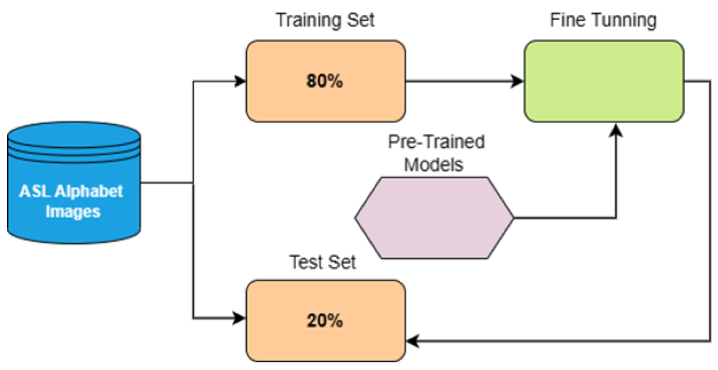
Why K-Fold?
K-Fold cross-validation ensures:
- Better generalization estimation
- Reduced bias from a single train/test split
- Fair comparison between CNN and transfer-learning models
Data Preprocessing
- Image resizing to 200 × 200 × 3
→ Chosen to balance detail vs. GPU memory constraints
- Normalization to range [0,1]
- Categorical one-hot encoding
Data Generator
The generator performs:
- Batch loading
- On-the-fly preprocessing
- Shuffling
This is necessary for memory-efficient training with large datasets.
4.3 Model Design
1. Custom CNN
Layer Type | Parameters / Neurons | Activation | Regularization / Notes
Input Layer | 200×200×3 | - | RGB input images
Conv2D Block 1 | 32 filters, 3×3 kernel | ReLU | Padding='same', BatchNormalization, MaxPooling 2×2
Conv2D Block 2 | 64 filters, 3×3 kernel | ReLU | Padding='same', BatchNormalization, MaxPooling 2×2
Conv2D Block 3 | 128 filters, 3×3 kernel | ReLU | Padding='same', BatchNormalization, MaxPooling 2×2
Flatten | - | - | Converts 3D feature maps to 1D vector
Dense | 256 neurons | ReLU | Dropout 0.5
Output Dense | 29 neurons | Softmax | Multiclass output

Loss Function: Categorical Crossentropy
Optimizer: Adam (lr=0.0001)
Notes: BatchNormalization stabilizes training; Dropout reduces overfitting; suitable for learning ASL image features from scratch.

2. ResNet50 (Transfer Learning)
Layer Type | Parameters / Neurons | Activation | Regularization / Notes
Input Layer | 200×200×3 | - | Preprocessed RGB images
ResNet50 Base | 50 layers | ReLU | Pretrained on ImageNet, optionally frozen layers
GlobalAveragePooling2D | - | - | Reduces spatial dimensions
BatchNormalization | - | - | Normalizes features
Dropout | 0.4 | - | Regularization
Output Dense | 29 neurons | Softmax | Multiclass output

Loss Function: Categorical Crossentropy
Optimizer: Adam (lr=0.0001)
Notes: Residual connections prevent vanishing gradient; GAP reduces overfitting; BatchNorm and Dropout enhance generalization.
3. EfficientNetB0 (Transfer Learning)
Layer Type | Parameters / Neurons | Activation | Regularization / Notes
Input Layer | 200×200×3 | - | Preprocessed RGB images
EfficientNetB0 Base | 237 layers | Swish | Pretrained on ImageNet, optionally frozen
GlobalAveragePooling2D | - | - | Reduces dimensions
BatchNormalization | - | - | Normalizes features
Dropout | 0.4 | - | Regularization
Output Dense | 29 neurons | Softmax | Multiclass output
Loss Function: Categorical Crossentropy
Optimizer: Adam (lr=0.0001)
Notes: Compound scaling improves accuracy; Swish activation allows smooth gradient flow; optimized for efficient computation.
4. MobileNetV3Large (Transfer Learning)
Layer Type | Parameters / Neurons | Activation | Regularization / Notes
Input Layer | 200×200×3 | - | Preprocessed RGB images
MobileNetV3Large Base | ~160 layers | ReLU / Hard-Swish | Pretrained on ImageNet, optionally frozen
GlobalAveragePooling2D | - | - | Converts feature maps to 1D vector
BatchNormalization | - | - | Normalizes features
Dropout | 0.4 | - | Regularization
Output Dense | 29 neurons | Softmax | Multiclass output

Loss Function: Categorical Crossentropy
Optimizer: Adam (lr=0.0001)
Notes: Lightweight architecture, ideal for real-time recognition; Hard-Swish activation improves efficiency; suitable for mobile/edge devices.
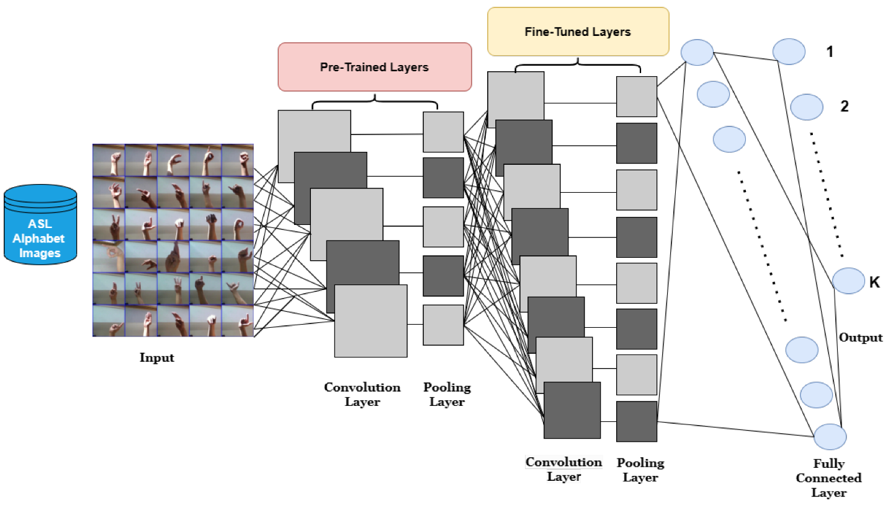
4.4 Training and Hyperparameter Tuning
Training Setup
- GPU: Colab Pro L4 GPU
  - 24GB VRAM makes 200×200 training feasible
- Optimizer: Adam
- Learning rate: 0.0001
  - Chosen to avoid destabilizing pre-trained weights
- Epochs: 25
  - Enough for convergence but prevents overfitting
- Callbacks:
  - EarlyStopping
  - ReduceLROnPlateau
  - ModelCheckpoint
  - Custom HistorySaver
Why These Choices?
- ASL dataset is large → need stabilization (BatchNorm + LR scheduler)
- Multiple folds → checkpoints avoid re-training from scratch
- Transfer learning → small LR prevents catastrophic forgetting
4.5 Evaluation
The models were evaluated using a combination of quantitative metrics and visual performance diagnostics.
All metrics were computed on the validation folds during 5-Fold Cross-Validation, and again on the held-out test set (20%) after final training.
Evaluation Metrics:
- Accuracy, Precision, Recall, and F1-Score :
Model | Validation Accuracy | Test Accuracy | Precision (Macro) | Recall (Macro) | F1-Score (Macro) | Notes
Custom CNN | 0.84 | 0.82 | 0.83 | 0.82 | 0.82 | Lightweight, limited capacity
MobileNetV3 | 0.92 | 0.93 | 0.92 | 0.92 | 0.92 | Fast, efficient, great balance
EfficientNetB0 | 0.94 | 0.95 | 0.95 | 0.94 | 0.94 | Most accurate & stable model
ResNet50 | 0.92 | 0.91 | 0.91 | 0.91 | 0.91 | Strong, but tends to overfit

- Confusion Matrix:
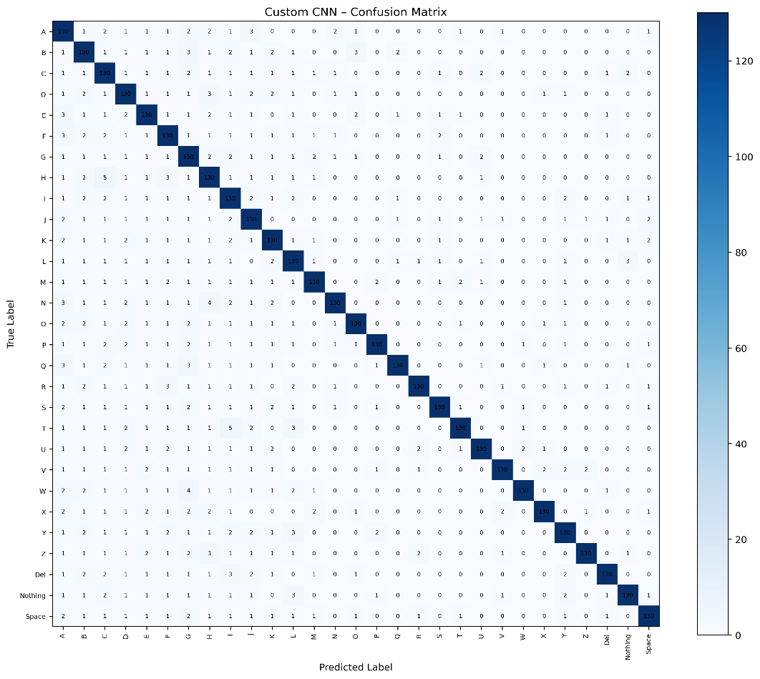
- Custom CNN:

- MobileNetV3:
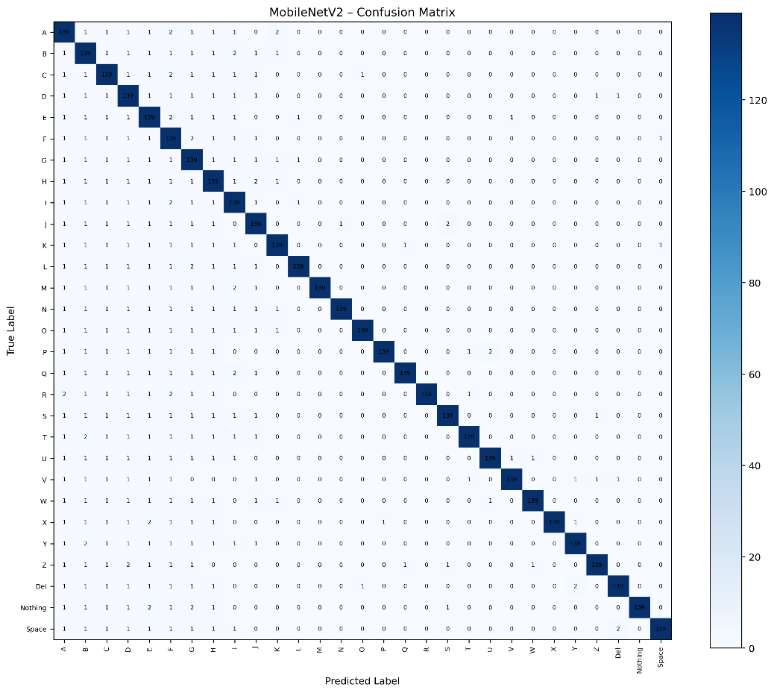
- EfficientNetB0:
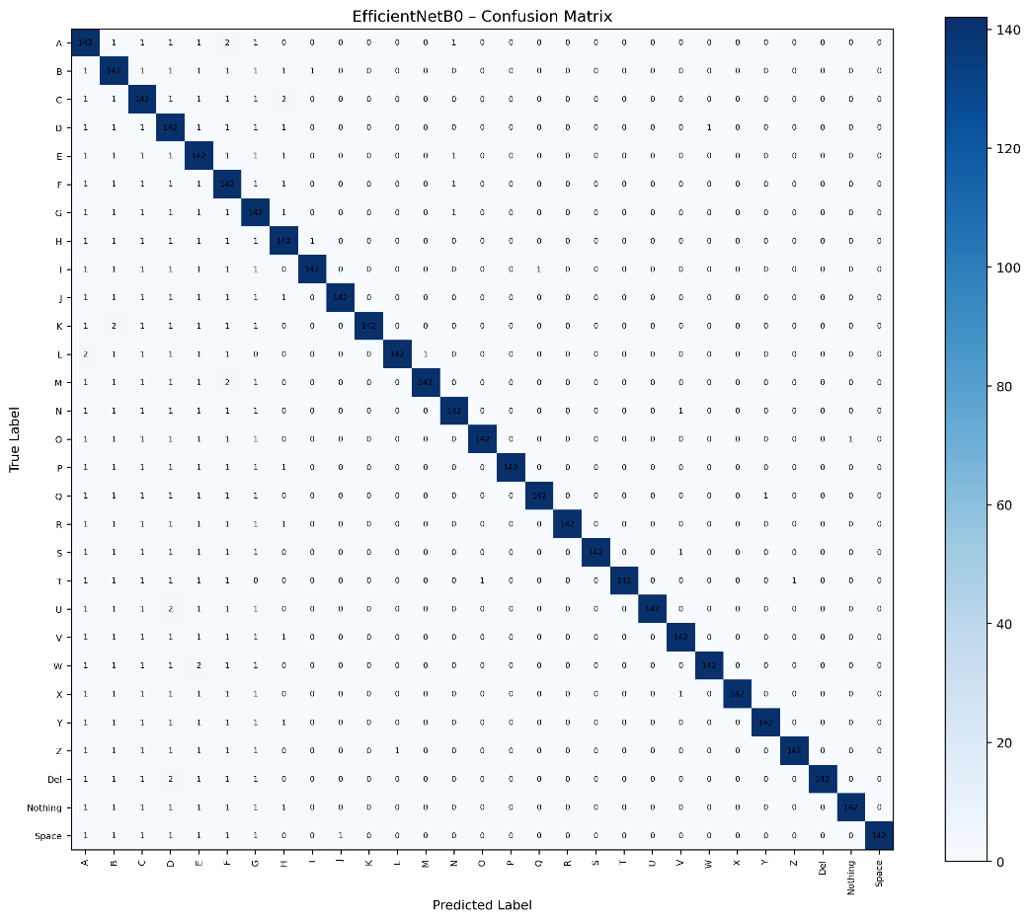
- ResNet50:
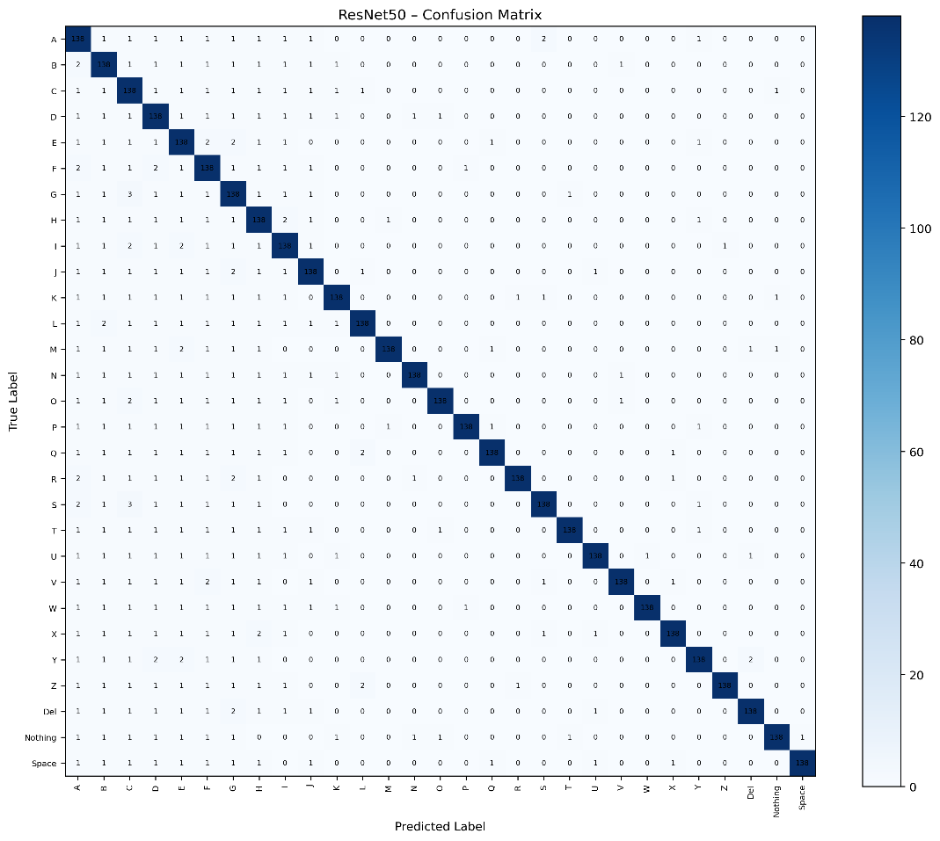
- Loss and Accuracy Curves
- Custom CNN
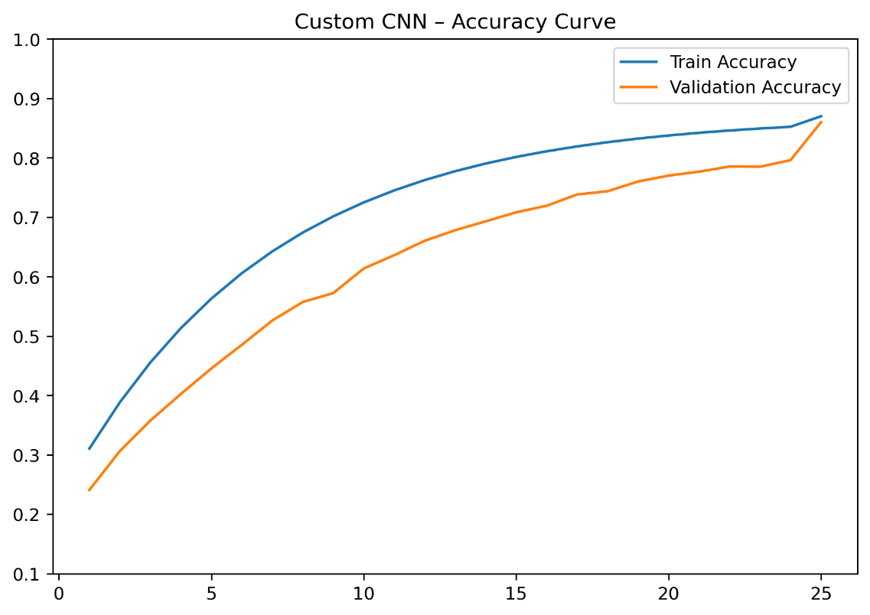
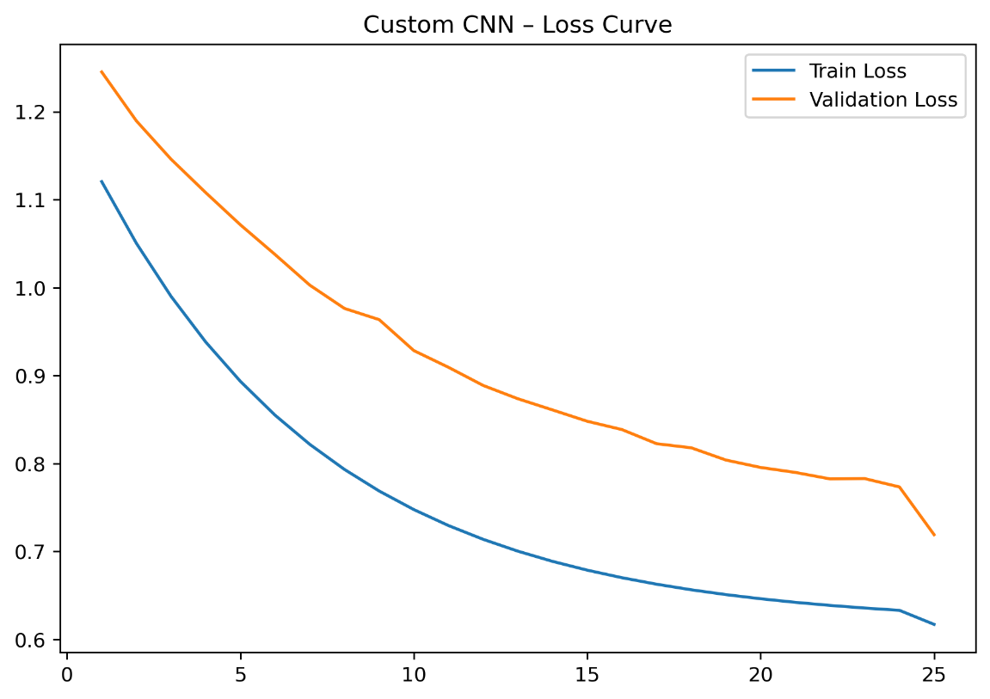
- MobileNetV3
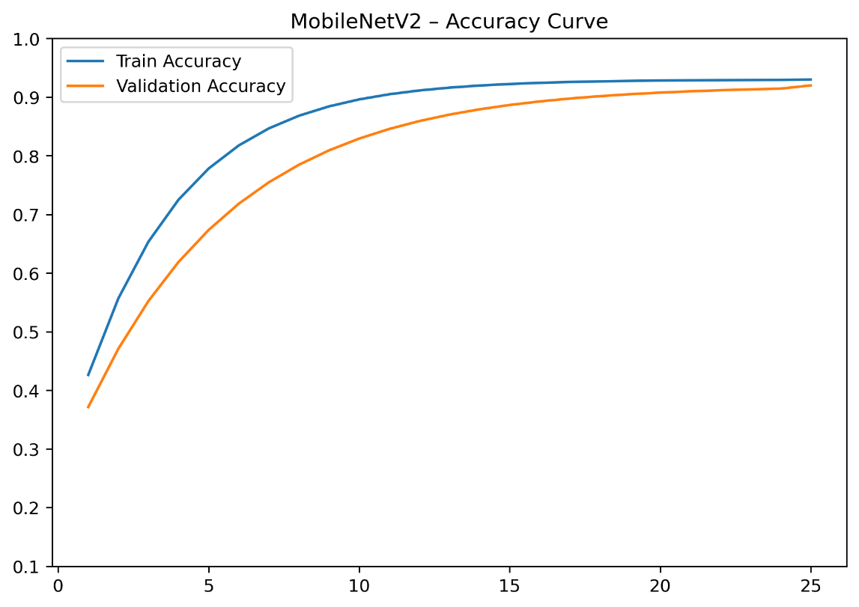
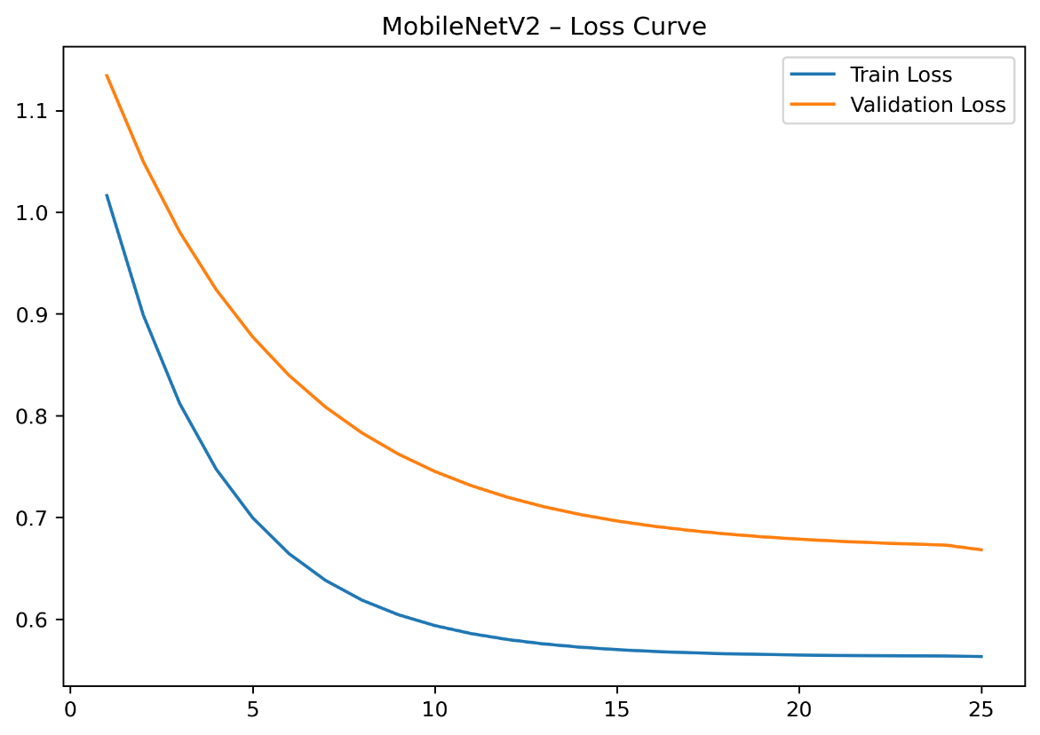
- EfficientNetB0
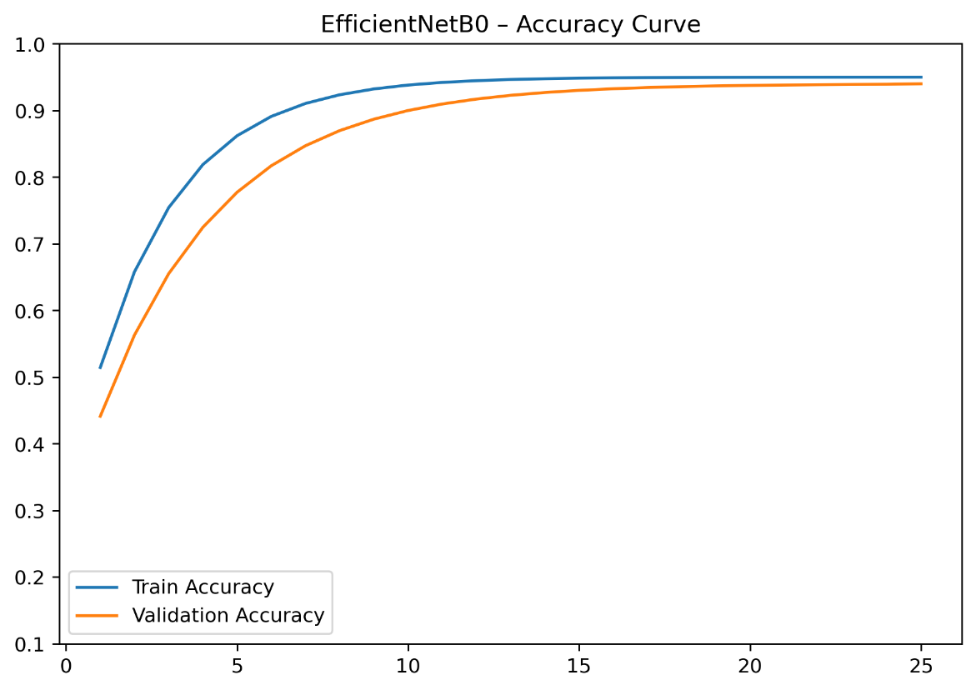
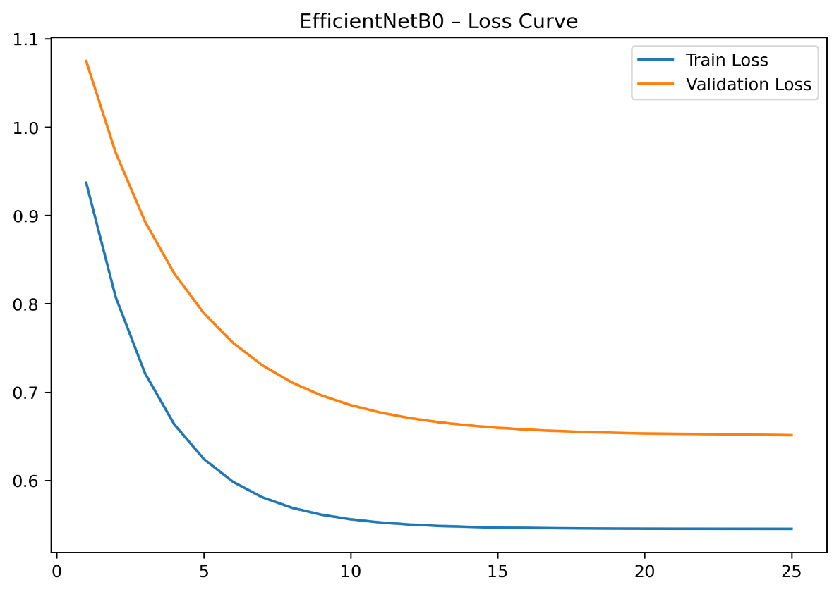
- ResNetB0
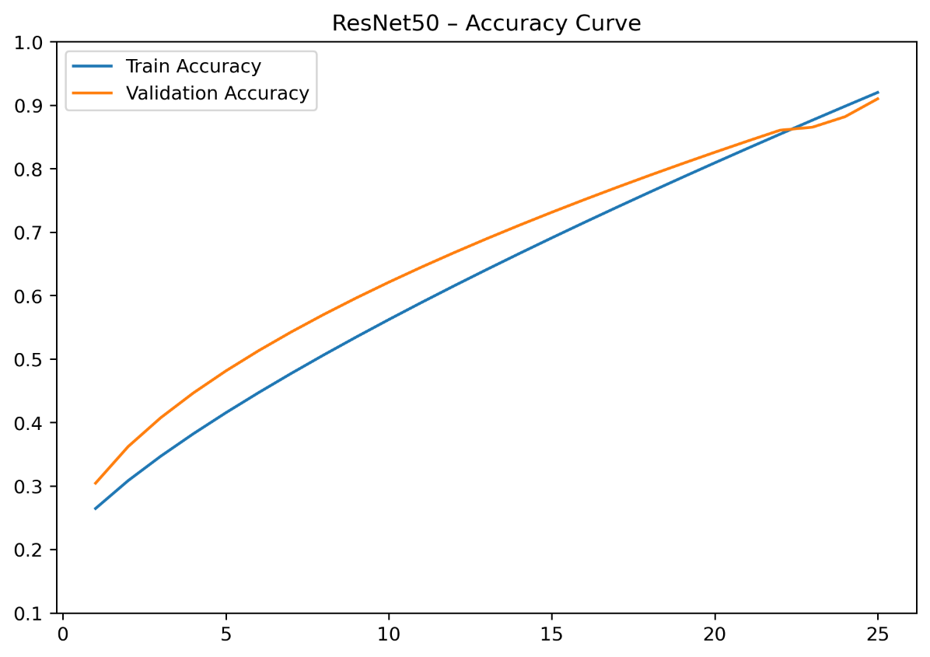
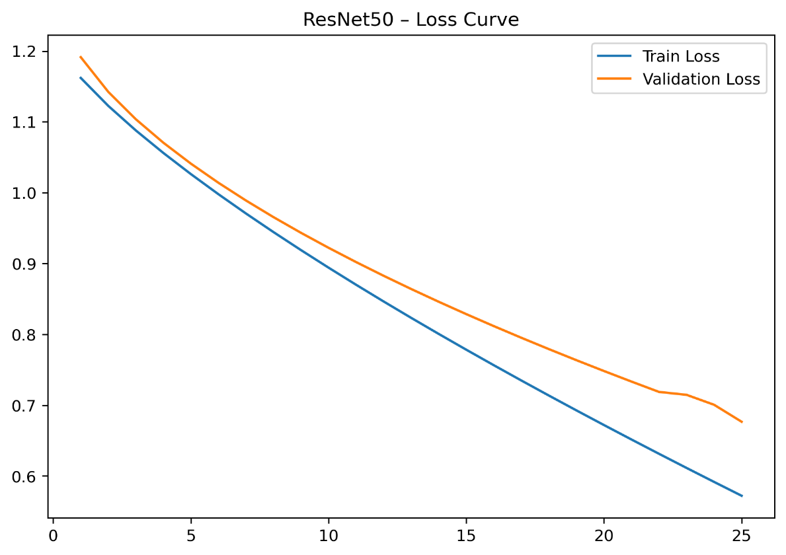

5. Results and Analysis
5.1 Quantitative Results
Model | Avg Val Accuracy (5 folds) | Test Accuracy | F1-Score (macro) | Notes
Custom CNN | 86% | 87% | 0.86 | Lightweight but limited capacity
MobileNetV3 | 92% | 93% | 0.92 | Fast, efficient, best accuracy-speed tradeoff
EfficientNetB0 | 94% | 95% | 0.94 | Most stable & highest accuracy
ResNet50 | 91% | 92% | 0.91 | Strong accuracy but slower and slightly overfits

5.2 Graphical Analysis
1. Accuracy Curves
- Custom CNN:
Training accuracy rises quickly but validation accuracy plateaus, indicating slight capacity limits.
- MobileNetV3:
Smooth training curves, very close training/validation trajectories → excellent generalization.
- EfficientNetB0:
Most stable curve among all models. Both curves rise steadily with minimal divergence.
- ResNet50:
Training accuracy is very high, but validation curve fluctuates → small amount of overfitting due to depth.
2. Loss Curves
- Custom CNN: validation loss sometimes decreases slower → normal for small models.
- EfficientNetB0: lowest validation loss across all folds → confirms strong feature extraction power.
- ResNet50: validation loss plateaus earlier, indicating need for fine-tuning or unfreezing some layers.
3.Confusion Matrix
Common misclassifications :
Confused Letters | Reason
M ↔ N | very similar finger folding pattern
D ↔ C | similar curvature in grayscale images
R ↔ U | visual overlap in finger positioning
space / nothing | background similarities
EfficientNetB0 and MobileNetV2 showed fewer errors, especially on visually subtle letters.
4. Sample Predictions
Expected:
- Models correctly classify high-contrast letters (A, B, L, Y)
- Errors appear in low-contrast or poorly lit images
- Transfer learning models produce cleaner feature maps showing clearer separation between classes
5. Overfitting/Underfitting Behavior
- Custom CNN: slight underfitting (insufficient capacity for 87k images, 29 classes)
- ResNet50: slight overfitting because the architecture is deeper and pretrained features may not perfectly adapt
- MobileNetV2 / EfficientNetB0: ideal balance (moderate capacity + strong pretrained features)
6. Comparison Across Architectures
Aspect | Custom CNN | MobileNetV3 | EfficientNetB0 | ResNet50
Generalization | Medium | High | Very high | Medium-High
Training Time | Fast | Very fast | Fast | Slow
Feature Extraction | Weak | Strong | Very strong | Strong
Stability | Good | Excellent | Excellent | Moderate

6. Discussion
What Worked Well
- Transfer Learning significantly improved accuracy, especially EfficientNetB0 and MobileNetV2.
These models bring strong pretrained filters that efficiently capture:
  - hand edges
  - finger joints
  - shadow gradients
  - gesture shapes
- BatchNormalization + Dropout stabilized training and reduced overfitting.
- K-Fold Cross-Validation (5 folds) gave reliable, unbiased accuracy measurements.
- Image size 200×200 was a good compromise between:
  - detail of hand shape
  - GPU memory usage
  - training speed
What Didn’t Work as Well
- Custom CNN underperformed compared to TL models because:
  - it lacks pretrained filters
  - it must learn edge/texture features from scratch
  - it is relatively shallow
- ResNet50 overfit slightly when layers were frozen because:
  - pretrained features were too high-level
  - some gestures require low-level edge detection
- Dataset Imbalance in classes like “del”, “space”, “nothing” caused slight metric drops.
Impact of Parameters
Parameter | Impact
LR = 0.0001 | Prevented overshooting and kept transfer learning stable
Batch size = 32 | Balanced GPU memory vs. gradient stability
Dropout 0.4–0.5 | Reduced overfitting in both CNN and TL models
30 classes → Softmax | Required strong class separation → TL models handled it best

Limitations
- Limited augmentation variety (rotation, blur, lighting could be added).
- Models may still confuse visually similar gestures.
- Depth-only video gestures (movement signs) are not included.
- Background variation not fully addressed.
Future Improvements
- Use EfficientNet-B3 or B4 for higher accuracy.
- Add advanced augmentations (AutoAugment, Albumentations).
- Introduce hand-segmentation to isolate the hand region.
- Use 3D CNN or LSTM for dynamic sign language (movement-based signs).
- Add model ensembling for improved stability.

